[Table_Main]
Research Report
30 Dec 2025
Bloom Energy Corporation (BE US)

A Solid Oxide Fuel Cell Player Set To Bloom In The Opportunity Of AI-Driven Onsite Power Generation Solutions: Initiation
 |  | Bloom Energy (BE) is positioned as a premier provider of Solid Oxide Fuel Cell (SOFC) technology, which is uniquely suited to address the surging power demand from the AI data center (AIDC) sector. As US electricity demand is projected to surge by up to 25% by 2030, the grid is failing to keep pace due to aging infrastructure and interconnection delays that can exceed nine years. BE’s time-to-power advantage allows for deployment in as little as 55 days, offering a alternative to multi-year utility wait times. This immediate scalability, combined with fuel cells’ superior electrical efficiency (exceeding 60%), makes BE a leading choice for hyperscalers requiring reliable, 24/7/365 constant full-load power.  The company’s strategic pivot toward the AI ecosystem is validated by a high-profile “lighthouse” customer base, including Oracle, Equinix, and a landmark $5 billion partnership with Brookfield Asset Management. Financial momentum is accelerating, evidenced by record Q3 2025 revenue of $519 million—a 57% year-over-year increase—and expanding non-GAAP gross margins of 30.4%. To meet this surging backlog, BE is doubling its manufacturing capacity to 2 GW by 2026, with further scalability up to 5 GW.  A bullish outlook for 2026. Beyond data centers, BE is successfully penetrating new verticals, such as gas providers, through innovative “go-to-market” strategies. BE’s modular architecture and leadership by industry veterans provide a stable foundation for growth. As on-site power generation transitions from a niche solution to a primary requirement for 27% of data centers by 2030, Bloom Energy is set for significant long-term expansion.  Valuation& recommendation  We initiate coverage on Bloom Energy with “Outperform”. Our 12-month price target is USD 138. We estimate the Non-GAAP EBITDA of BE from year 2025 to 2028 will be USD 215/ 379/ 1,221/2,122 million, reflecting upsides to expectations for ramping revenue and margin. We assign a 26X FY28E EV/EBITDA to our FY28E Non-GAAP EBITDA, as we believe a premium is justified given elevated power demand needs with continued execution and order announcements with improving visibility from recent deals, including the Brookfield partnership.  Risks  Change of base-load power supply bottleneck status; Regulatory limits; Concerns around future cost-savings.
  [Table_Info]
  Initiate with OUTPERFORM
  Rating | OUTPERFORM
  Current Price | 91.43
  Target Price | 137.81
  Market cap | 21.624bn
  Shares in issue | 237mn
  1 yr high - low | 142.37-16.32
  Note: Current Price 356.36 is the close price on 23 Dec 2025
  Source: Company, HFI
  [Table_Profit]
   | Dec-24A |  | Dec-25E |  | Dec-26E |  | Dec-27E
  Revenue | 1,473.9 |  | 1,858.7 |  | 2,341.6 |  | 4,556.6
  (+/-) | 10.5% |  | 26.1% |  | 26.0% |  | 94.6%
  Net Profit | 64.6 |  | 115.6 |  | 243.0 |  | 1,070.4
  (+/-) | - |  | 79% |  | 110% |  | 341%
  EPS | 0.28 |  | 0.38 |  | 0.78 |  | 3.40
  GPM | 28.7% |  | 29.6% |  | 32.4% |  | 35.5%
  ROE | -1.4% |  | -2.6% |  | 3.9% |  | 16.9%
  P/E | 327 |  | 240 |  | 118 |  | 27
  Source: Company, HFI
[Table_Author]
Bin Yang
harryyang@hfisec.com.hk

Contents

1. Bloom Energy: Provides an Distributed Electric Power Generation Solution 1
1.1 Converting natural gas to electricity, without combustion 1
1.2 Financial performance highlights 8
2 SOFC: A New Solution for AIDC Power Supply 10
2.1 US hyperscalers resorting to on-site power 10
2.2 SOFC: an ideal onsite power generation solution 13
3 Bloom Is Set to Bloom 15
3.1 Building and executing on order backlog 16
3.2 A new “go-to-market” strategy 16
4. Valuation& recommendation 17
5. Risks 18

- Bloom Energy: Provides an Distributed Electric Power Generation Solution

1.1 Converting natural gas to electricity, without combustion

Bloom Energy is an leading producer of solid oxide fuel cells (SOFC), which run on natural gas to produce electric power without combustion. The company is headquartered in San Jose, CA.

Its flagship commercial offering is the Bloom Energy Server Series 10, which is particularly tailored for the rapid-growth data center and large-scale industrial markets. The Series 10 is a modular 10 MW fuel cell block designed for unprecedented speed-to-market, capable of being shipped in as little as 50 days vs 9 to 12 months pre-2022. Technically, the Series 10 leverages BE’s solid oxide technology to provide 24/7 “AlwaysOn” power with 100% output guaranteed, is net-zero compliant, and is fuel-flexible—meaning it can run on natural gas today and transition to 100% hydrogen in the future without hardware changes.

Figure: BE’s SOFC converting natural gas to electricity, without combustion
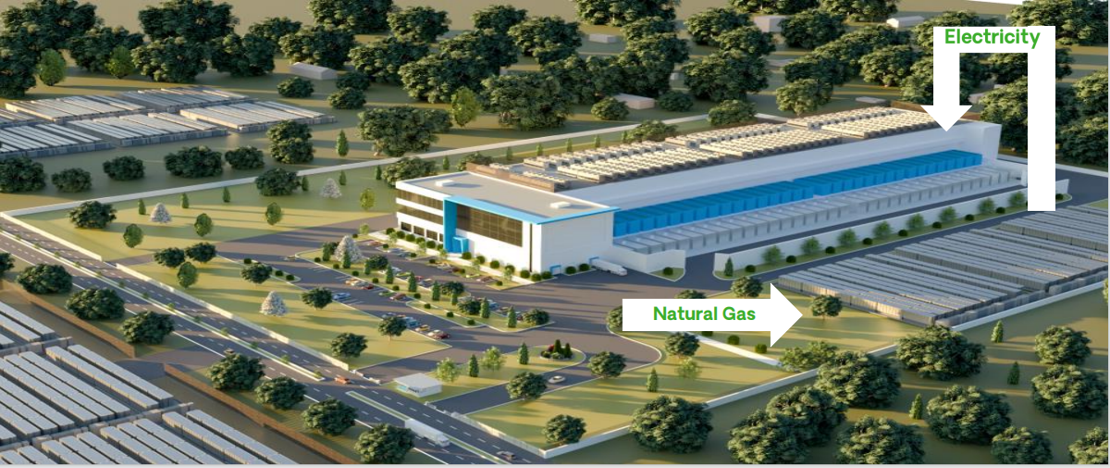
Source: Company, HFI

Figure: Bloom Energy Server Series 10 specifications
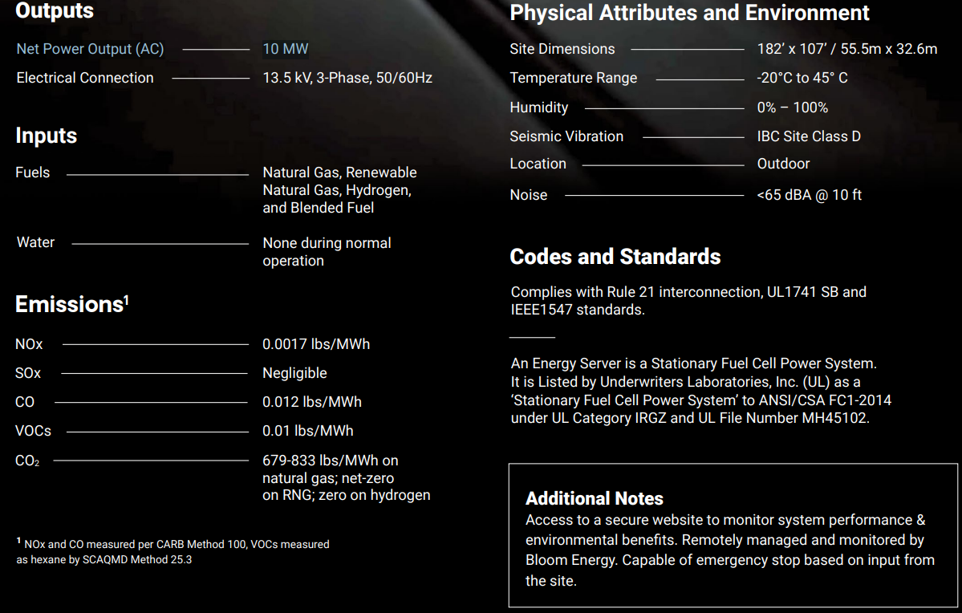
Source: Company, HFI

BE is also a producer of Solid Oxide Electrolyzers Cells (SOEC) with its product Bloom Electrolyzer, which generates hydrogen from electricity, providing clean, carbon-free fuel for power generation. Running at high temperatures and high availability, the pilot results reveal the Bloom Electrolyzer is producing hydrogen at 37.5 kWh per kilogram of hydrogen at the system level. Alternative efficient electrolyzer technologies, such as PEM or Alkaline, consume as much as 52 – 54 kWh per kilogram of hydrogen produced.

BE operates in four business segments: Product, Installation, Service and Electricity:

Product segment is the primary engine of revenue, including two products: the Bloom Energy Server for generating electricity and the Bloom Electrolyzer for producing hydrogen. While the Bloom Electrolyzer is transitioning to commercial scale, nearly all of the product revenue has been attributable to sales of the Energy Server system. Overall, Product contributes over 70% of total revenue with non-GAAP gross margins expanding toward 36% as of 3Q25. This growth is driven by massive “gigawatt-scale” agreements, such as the $5 billion landmark partnership with Brookfield Asset Management. We believe further manufacturing capacity additions to capture the AI power demand bloom should drive revenues higher while margins should benefit from fixed cost absorption as utilization ramps up.

Installation is simply the extra costs associated with installing fuel cell systems at customers’ sites. Installation contributes over 10% of total revenue. While historically a low-margin drag, the segment has a 10% gross margin as of 3Q25, as the costs are increasingly optimized through better plant designs and the rapid “90-day” deployment strategy for high-load customers.

Service segment revenue are driven by maintenance and repair work done on fuel cell. Service accounts for more than 10% the total revenue and has undergone a successful turnaround, marking seven consecutive quarters of profitability by 3Q2025. The segment now generates double-digit non-GAAP gross margins (reaching 14.4% in
3Q25). This shift is the result of improved fleet reliability and the phasing out of older, high-maintenance legacy equipment in favor of newer, more efficient server generations.

Lastly Electricity contains the PPAs under which BE previously sold many of its fuel cell systems. The customer would pay BE for the power rather than the fuel cell itself and BE would typically execute a sale-leaseback or tax equity finance the asset. This segment accounts for 2% of revenues and generates 43.5% gross margins in 3Q25. The company has moved away from PPAs and intends to simplify the remaining PPA structures over time.
Figure: BE’s revenue by segments and Non-GAAP gross profit by segments
Source: Company, HFI

BE maintains a vast and diverse customer footprint, covering not only data centers but also commercial and industrial (C&I) users, with 1.5GW+ applications in 1200+ location as of end Q3 2025 globally. BE’s strategy is deliberate and simple. In each vertical, BE establish credibility with a lighthouse account and then build on that success with other tier-one customers. BE ran this playbook last decade in the telecom business, landing first AT&T in 2011 and then competitors like T-Mobile to become “the standard for on-site power” in that industry. Today, BE are a go-to onsite power choice for US telecom companies and it is following the same playbook to become the standard onsite power solution for AI.

Figure: BE’s diverse customer footprint, with Growing AI Concentration
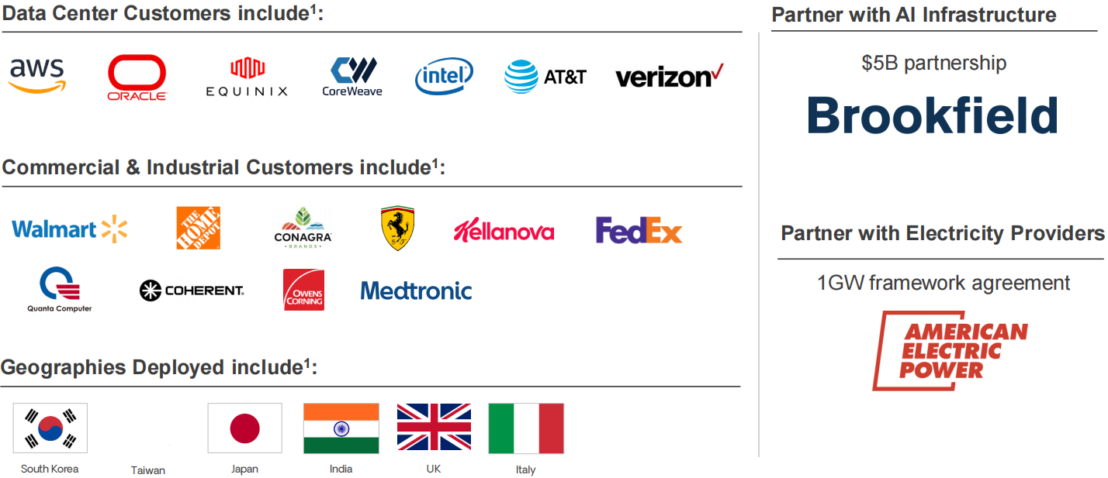
Source: Company, HFI

With the AI up-cycle, the company has strategically pivoted toward the AI ecosystem, which has become its dominant growth engine. BE now has secured “lighthouse” partnerships with hyperscalers like Oracle; electricity providers like American Electric Power (AEP), which sells power to Amazon Web Services; colocation firms like Equinix, “neoclouds” like Coreweave, gas providers, and data center developers. In October, BE announced an $5 billion strategic AI infrastructure partnership with Brookfield Asset Management, signaling cooperation with large infrastructure funds. In addition, due to BE’s proprietary technology, there is a 100% attach rate of services to product sales. C&I customers typically sign service agreements of approximately 15 years, while data center customers average closer to 5-6 years to more closely align with GPU depreciation schedules.

BE is doubling its manufacturing capacity to 2 GW by 2026 to support its AIDC concentration, positioning its SOFC as mission-critical infrastructure for the accelerating digital revolution. The process is expected to take 6-9 months. The company noted that the $100-150mm capex spend to expand capacity by to 2 GW can be potentially paid back in less than a year. We believe this relatively capex-light capacity expansion provides reason to believe the company can scale capacity as needed, based on sustained customer demand. In addition, the current facilities in Fremont, California and Newark, Delaware are designed to be scalable up to 5 GW as needed.

Table: BE's AI & Data Center Milestones
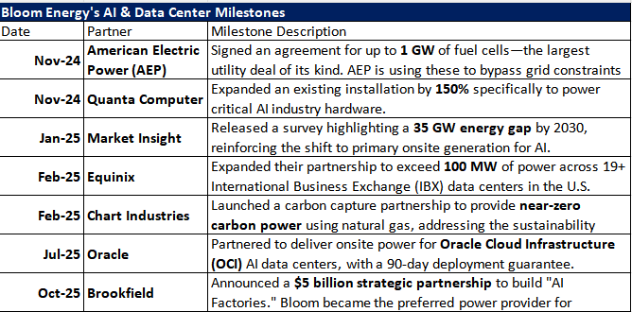

Source: Finance Yahoo, HFI

Figure: BE’s CA and DE Factories
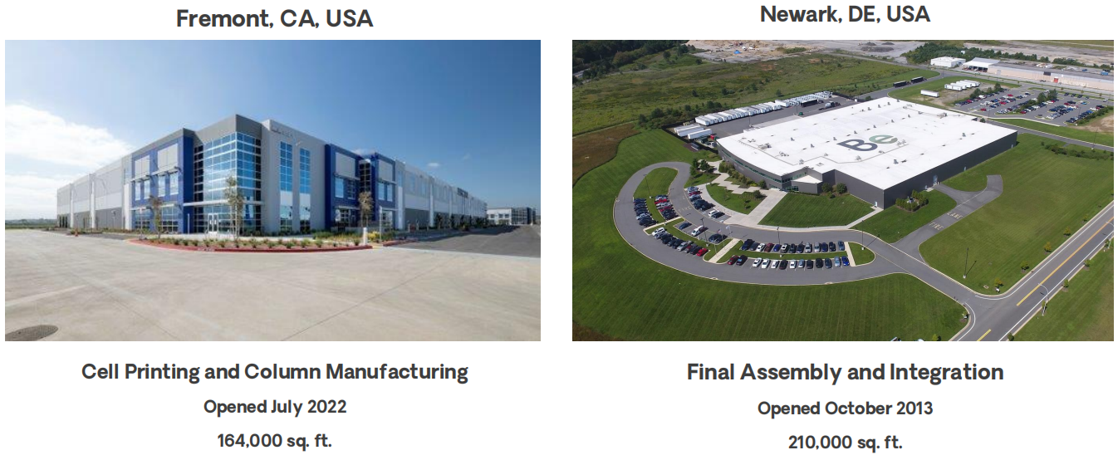
Source: Company, HFI

BE is steered by a leadership team of seasoned visionaries and industrial experts, leading by its Founder and CEO, Dr. KR Sridhar, a former NASA scientist whose work on Mars oxygen technology forms the company's core platform. The management team includes Aman Joshi (Chief Commercial Officer), who spearheads the company’s pivot to AI and data centers, Satish Chitoori (COO), who oversees global manufacturing expansion, and Ravi Prasher (CTO), who leads R&D in fuel cells and hydrogen. The strategic direction is further strengthened by a high-profile board featuring industrial veterans like Jeff Immelt (former GE CEO), John Chambers (former Cisco CEO), and Jim Hagemann Snabe (Chairman of Siemens).

Figure: Leadership Team & Board
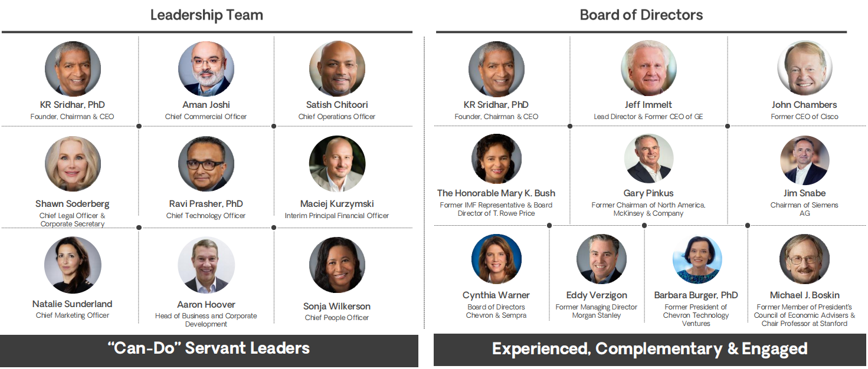
Source: Company, HFI

BE’s ownership structure is predominantly institutionally held. As of September 30, 2025, Ameriprise Financial Inc. is the largest shareholder with a 12.54% stake, while the top four shareholders—Ameriprise Financial Inc., Vanguard Group Inc., Blackrock Inc., and D. E. Shaw & Co., Inc.—collectively hold approximately 35.08%. This high level of institutional ownership, which rose to 97.69% in Q3 2025, provides stable governance support and signals strong external confidence in the company's large-scale commercialization potential.
Figure: BE's top four holders
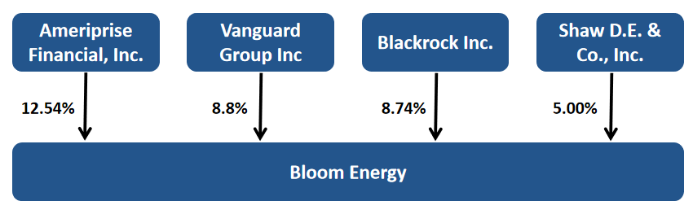
Source: Finance Yahoo, HFI

1.2 Financial performance highlights
BE achieved a landmark performance in the third quarter of 2025, with total revenue reaching a record $519.0 million—a staggering 57.1% year-over-year increase from $330.4 million in Q3 2024. This growth was primarily catalyzed by unprecedented time-to-power needs from the AI sector, most notably evidenced by the recognition of $288 million in revenue related to the newly announced $5 billion strategic partnership with Brookfield.

It is worth noting that the revenue growth slowed during 2022-2024 due to a strategic pause in South Korea, its largest international market, as the company adapted to new government clean energy policies. This transition created a lack of clarity regarding shipment timings and project bidding. Domestically, growth was hindered by extended
sales cycles for large-scale projects and phase-out of Electricity revenue during the same period. These headwinds are now behind the rearview mirror.
Figure: BE’s 2021-2025Q3 Revenue (USD mn) & YoY (%)
Source: Company, ifind,HFI

The company's profitability also saw significant expansion. Non-GAAP gross margin rose to 30.4%, up 2.2 percentage points from Q2 2025, driven by a decade-long trend of reducing manufacturing costs through engineering innovation and economies of scale. Furthermore, BE reported a Non-GAAP operating margin of 8.9%, a sequential increase from 7.1% in Q2 2025. This improvement reflects enhanced operational leverage and disciplined efficiency across R&D and G&A functions, even as the company prepares to double its manufacturing capacity to 2 GW by late 2026 to meet its surging AI-driven backlog.
Figure: BE’s 2021-2025Q3 GP (USD mn) & GM (%)
Source: Company, ifind,HFI

Figure: BE’s 2021-2025Q3 OP (USD mn) & OM (%)
Source: Company, ifind,HFI

The company reaffrimed its guidance in Q3 and expects FY25 results to be above the high-end of the existing guidance range, though specific guidance was not set due to timing of a large data center project announcement before year-end. With milestones deals with AIDCs stakeholders, we believe that BE’s ability to deliver power in as little as 55 days (as seen with Oracle) provides a critical competitive advantage over the multi-year wait times associated with traditional utility grid connections.

Table: Reaffirming 2026 Guidance
 | 2025 Outlook
Total Revenue | $1.65B-$1.85B
Non-GAAP Gross margin | ~29%
Non-GAAP Operating Income | $135M-$165M

Source: Company, HFI

2. SOFC: A New Solution for AIDC Power Supply

2.1 US hyperscalers resorting to on-site power
Recent years have seen a dramatic pivot in US electricity demand, driven largely by the rapid expansion of AIDCs. After decades of relatively flat consumption growth, total US electricity demand is now projected to surge by as much as 25% by 2030, according to ICF. Growth is largely propelled by the computational needs of generative AI, which requires 24/7/365 constant full load power capacity to be online within 6 to 12 months.

In addition, the usage pressure has become more acute for some regions in recent 2 to 3 years. As hyperscalers rush to build the infrastructure necessary for generative AI training and inference, regions like CAISO, ERCOT, and SWPP saw AIDC build-ups accounting for c.10% mix of total electricity demand, while PJM has c.21% demand contributed by DCs.

Figure:US DC power demand by ISOs/RTOs
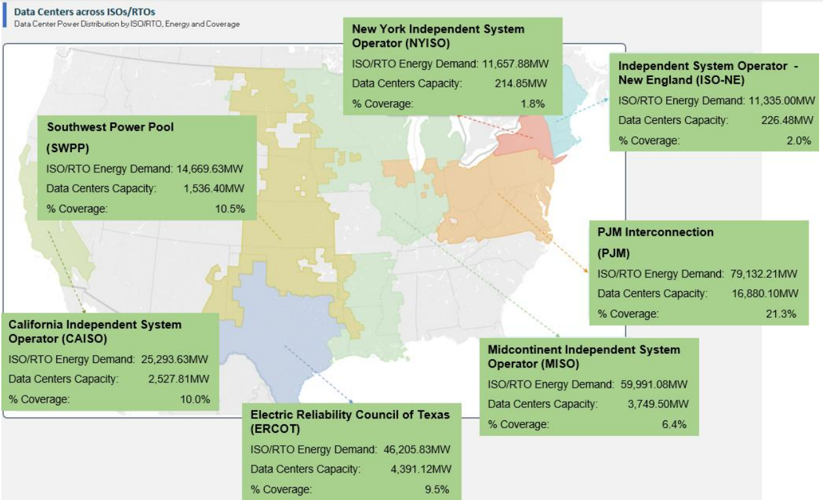
Source: FERC, HFI

Furthermore, as more AIDCs being built, they are becoming more power-hungry. With the widespread adoption of AI, we see a further speed-up in data centre construction in 2026 validated by the heightened capex guidance provided by the leading US hyperscalers in 2025. Also, AIDCs also getting bigger with the expected median size of an AI data center to reach 250–300 MW by 2030—a 50% increase over current levels. This shift is fueled by surging demand for both training and inference, alongside the deployment of high-performance hardware like NVIDIA’s Blackwell GPUs, which consume approximately 1,000 watts per unit.

Figure: US rising full-year capex guidance from key hyperscalers, 1Q25-3Q25 (USD bn)
Source: Bloomberg, HFI

Supply and the grid is not keeping pace with the rocketing power demand, however. The total effective capacity grew by only 2% from 2019 to 2024. While the US added over 160 GW renewable assets from 2019 to 2024, they have low effective capacity factors (i.e., portion of time actually generating electricity) as solar only works with the sun is out and wind turbines only when there is sufficient wind. Retiring 59G of coal capacity over the same period compound the problem, causing an overall 36GW net decline in dispatchable power. Also, the US has lagged in adding transmission capacity primarily due to aging infrastructure, the immense difficulty of obtaining land-use permits for cross-state lines, and a massive backlog in the interconnection queue that may even take over nine years to clear.

Table: More renewable less coal makes capacity additions smaller than they appear
Power supply capacity addition over 2019-2024
Nameplate capacity (GW) | 2019 | 2024 | % change
Dispatchable power | 947 | 912 | -4%
Intermittent | 250 | 413 | 65%
Total | 1,198 | 1,325 | 11%
Capacity factor
Dispatchable power | 58.80% | 58.10%
Intermittent | 41.30% | 34.80%
Effective Capacity
Dispatchable power | 557 | 530 | -5%
Intermittent | 103 | 144 | 39%
Total | 660 | 674 | 2%

Intermittent power generation (e.g., solar, wind) generate electricity less often than dispatchable power
Source: EIA, HFI

Figure: US interconnection wait times at key ISOs (years)
Source：Everus Power &Renewables, HFI

Consequently, data center developers are turning to on-site power generation solution. With on-grid solutions unable to meet immediate needs, on-site powers are gaining traction for DCs that face limited grid access but need fast, reliable start-up. On-site microgrids, combining distributed energy resources and battery storage (BESS), provide a flexible, locally controlled power solution that boosts reliability, cuts transmission losses and lowers reliance on diesel generators as back-up power.

Also, regulations are pushing on-site power generation as well directly or indirectly. The proposed federal rules would favor data centers that have collocated power generation. State rules are likely to increase the electricity costs through either higher rates, contract terms, or renewable requirements. Both trends make on-site generation more attractive, in our view.

Based on a survey pulled by Bloom Energy, 27% of data centers decision makers in April 2025 said they will be fully powered by on-site energy sources by the year 2030 vs. 1% in one year earlier.

Table: Examples of recent regulatory actions
Examples of recent regulatory actions
Federal | October | Secretary of Energy Chris Wright initiated rulemaking to accelerate connection of large loads, historically defined as over 20 megawatts (MW) with the aim to "ensure efficient, timely, and non-discriminatory load interconnections." Data centers that add on-site power generation or agree to voluntarily reduce demand during peak times could get expedited reviews (e.g., 60 days versus current years-long processes).
State | April | South Carolina’s state-owned utility began charging a higher rate to customers >50 MW.
State | June | Texas passed legislation (SB 6) that requires the PUCT to create rules that large load customers (>75 MW) contribute to interconnection costs and agree "only after all available market services have been deployed" to use backup generating facilities during emergencies.
State | July | the Public Utilities Commission of Ohio ordered AEP Ohio to file new tariffs applying to data centers.
State | August | the Arkansas Public Service Commission approved Arkansas Electric Cooperative Corporation new Transmission Extension of Facilities Tariff, which puts higher costs to customers exceeding 50 MW.

Source: Bloomberg, HFI

Figure: 27% of DC cites says they will have 100% onsite power generation in 2030
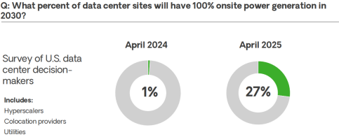
Source: Company, HFI

2.2 SOFC: an ideal onsite power generation solution
SOFCs generate electricity through electrochemical reactions—without combustion. They use a solid ceramic electrolyte that conducts oxygen ions at high temperatures (600–1,000°C). Air flows to the cathode, where oxygen molecules gain electrons and become oxygen ions. These ions travel through the electrolyte to the anode, where they react with fuels like hydrogen or natural gas, producing water, carbon dioxide (if using hydrocarbons), and releasing electrons. The electrons flow through an external circuit, creating usable electric current before returning to the cathode.

Figure: How Fuel Cell Technology Provides Electric Power
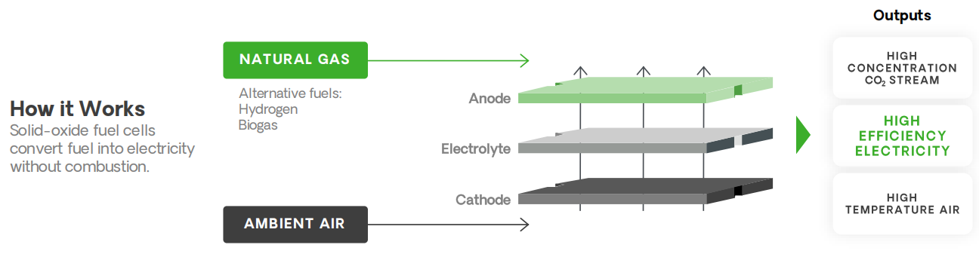
Source：Company, HFI

Popular onsite power generation technology routes includes nuclear, gas turbines, solar, SOFC and SMR. We summerized the key elements below, while cost is important (measured by LCOE), developers also prioritize speed to market (Time to power) and physical constraints (Land and Siting):
Table: Different technology routes of onsite power generation
Technology | LCOE ($/MWh) | Time to power | Land need for co-location | Siting challenge
Solar + 4 hour storage | $81-135 | 1-2 years* | Large | Low
Large sized gas turbines | $70-80 | ~4 years | Small | Mid
Medium sized gas turbines | $80-90 | ~2 years | Small | Mid
Gas engines | $110-120 | 1-2 years* | Small | Mid
Solid Oxide Fuel Cell-NG | $90 | <1 year | Small | Mid
Nuclear-new | $180 | >10 years | Large | High
Nuclear-operating | $80-90 | 1-2 years* | High | Low
SMR | $88-155 | >5 years | Small | High

*does not include interconnection queues and permiting delays that can add up to 5-7 years
Source：BloombergNEF, Wood Mackenzie, NREL, HFI

The comparison suggests that data center developers are facing a balancing act. While DC developers evaluating more than just cost in technology decisions, SOFCs are structurally advantaged for DC applications offering higher efficiency, modularity and shorter lead times than gas turbines.

- Excellent time-to-power capacity: SOFC Orders can be deployed in a matter of months (or within 90 days in the case of Bloom Energy’s deal with Oracle), whereas utility connection can take years in some parts of the US and 3+ years lead times for gas turbines. Other distributed power options, such as solar-plus-BESS systems and operating nuclear plant co-location solutions, require extra regulatory approvals and potentially substantial land area.

Figure: GEV’s massive gas turbines backlogs in 2028
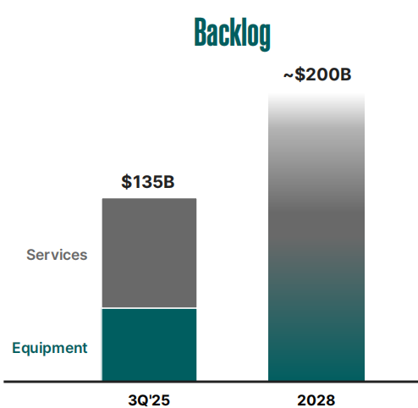
Source: GEV, HFI

- Higher Efficiency: SOFCs convert chemical energy directly into electricity via electrochemical reactions, bypassing the thermal losses of combustion engines. This allows them to achieve electrical efficiencies exceeding 60%, which makes up for higher OpEx from a shorter designed lifecycle of 5-7 years. Crucially, SOFCs maintain high efficiency during "part-load" operations, whereas gas turbines suffer significant efficiency drops when not running at peak capacity.

- Modularity: Built from scalable, independent power stacks, SOFCs offer a "Lego-like" architecture. This allows operators to add power capacity in small increments to match IT load growth, preventing the massive upfront over-provisioning required by large turbines. This modularity also enhances redundancy; a single module failure does not compromise the entire facility's uptime.
Figure: BE’s product modularity
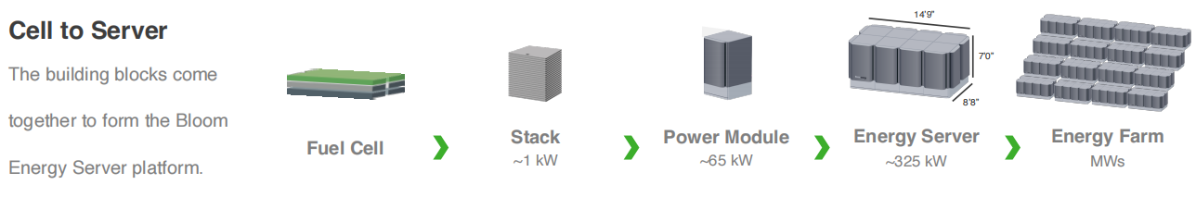
Source：Company, HFI

3. Bloom Is Set to Bloom
we are bullish on Bloom into 2026 on increased demand for micro-grid solutions that offer 24x7 power, execution against building the backlog, and further increased penetration. We see a substantial power bottleneck emerging in the next 3 years and would expect to see further evidence of this trend in 2026 as utility interconnect times get longer, onsite power solutions are pursued more broadly, and power prices rise in the market.

3.1 Building and executing on order backlog

Building and Executing on Order Backlog: BE is poised to showcase robust execution in delivering on its expanding backlog, fueled by key high-profile contracts secured in 2025. BE delivered volumes for first ORCL site within 55 days (revenue recognized in 3Q) vs 90 day commitment. We think smooth execution here could lead to follow-on orders with Oracle, and the company indicated it is working on multiple potential project opportunities with Oracle. Brookfield also plans to announce a Bloom-powered European AI inference data center project by the end of the year and may want to triple the investment very quickly in the next two to three years. Notable signs of advancement of the agreement with AEP regarding the remaining 900MW orders surfaced in 2025, including regulatory approvals, may also lead to further expansion orders to roll out going forward.

3.2 A new “go-to-market” strategy

A new “go-to-market” stategy: Bloom Energy (BE) has introduced a novel go-to-market strategy by securing a Q3 agreement with a major gas provider. Under this deal, the provider will utilize BE’s fuel cells to convert natural gas into onsite electricity for a hyperscale data center. This aligns with a growing trend where oil and gas firms, such as Williams (WMB) and Liberty Energy (LBRT), are exploring fuel cells for data center power. We view this contract as a significant validation of BE’s technology and a catalyst for further expansion into this vertical. As BE prepares to double its capacity to 2 GW next year, this momentum strengthens its status as a scalable leader in onsite power.

4. Valuation& recommendation

We initiate coverage on Bloom Energy with “Outperform”. Our 12-month price target is USD 138. We estimate the revenue of Bloom Energy from year 2025 to 2028 will be USD 1,859/ 2,342/ 4,557/ 7,274 million, with the Non-GAAP EBITDA of USD 215/ 379/ 1,221/2,122 million, reflecting upside to expectations for ramping revenue and margin. We assign a 26X FY27E EV/EBITDA to our FY28E Non-GAAP EBITDA, as we believe a premium is justified given elevated power demand needs with continued execution and order announcements with improving visibility from recent deals, including the Brookfield partnership.

Table: Valuation Model
EV/EBITDA Valuation
Valuation Terminal Date | 12/31/2028
Non-GAAP EBITDA 28E | 2,122.0
EV/EBITDA | 26
EV 28E | 55,172
Total Debt 28E | 2,694
Total Cash 28E | 2,082
EquityValue 28E | 54,560
Diluted Shares 28E | 316
PT 28E | 173
Discounted Rate | 12%
PT 12-month | 137.81
Current | 92
Upside/Downside | 50%

Source: Company, HTI

Table: Financial Summary
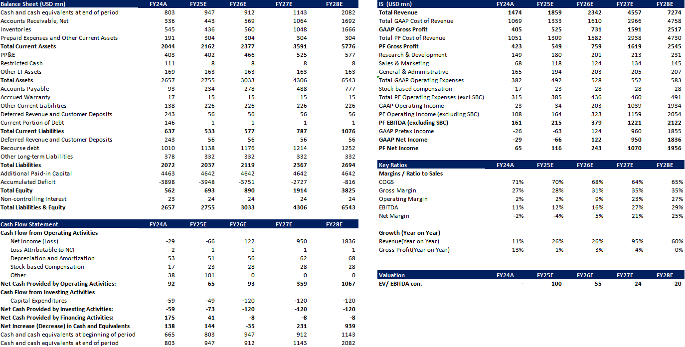
Source: Company, HTI

5. Risks
Change of base-load power supply bottleneck status: potential easing of the power-grid interconnection queue; an increase in gas turbine supply; potential competition from other power sources; any higher-than-company-expected order intake leading to potential tightness in production capacity.

Regulatory limits: change in the gas-pipeline regulatory process; ITC policy requirements for FCs

Concerns around future cost-savings: below-expectation cost-savings with scale and efficiency improvements; higher opex from a shorter designed lifecycle of 5-7 years.

[Table_disclaimer]
附录APPENDIX
重要信息披露
本研究报告由华福国际（香港）金融控股有限公司（下称华福国际）分销，在其许可的司法管辖区内从事证券活动。
IMPORTANT DISCLOSURES
This research report is distributed by HuaFu International (HK) Financial Holdings Limited (referred as HuaFu International below), which is authorized to engage in securities activities in its respective jurisdiction.
分析师认证Analyst Certification:
我， xxxx，在此保证（i）本研究报告中的意见准确反映了我们对本研究中提及的任何或所有目标公司或上市公司的个人观点，并且（ii）我的报酬中没有任何部分与本研究报告中表达的具体建议或观点直接或间接相关；及就此报告中所讨论目标公司的证券，我们（包括我们的家属）在其中均不持有任何财务利益。I, xxxx, certify that (i) the views expressed in this research report accurately reflect my personal views about any or all of the subject companies or issuers referred to in this research and (ii) no part of my compensation was, is or will be directly or indirectly related to the specific recommendations or views expressed in this research report; and that I (including members of my household) have no financial interest in the security or securities of the subject companies discussed.
利益冲突披露Conflict of Interest Disclosures
华福国际及其某些关联公司可从事投资银行业务和/或对本研究中的特定股票或公司进行做市或持有自营头寸。就本研究报告而言，如需了解其中提到的某一公司信息，请发邮件至lcd@hfisec.com.hk）
HuaFu International and some of its affiliates may engage in investment banking and / or serve as a market maker or hold proprietary trading positions of certain stocks or companies in this research report. As far as this research report is concerned, please send an email to lcd@hfisec.com.hk if the information about any company mentioned in this report is needed).
评级定义（从2020年7月1日开始执行）：
华福国际采用相对评级系统来为投资者推荐我们覆盖的公司：优于大市、中性或弱于大市。投资者应仔细阅读华福国际的评级定义。并且华福国际发布分析师观点的完整信息，投资者应仔细阅读全文而非仅看评级。在任何情况下，分析师的评级和研究都不能作为投资建议。投资者的买卖股票的决策应基于各自情况（比如投资者的现有持仓）以及其他因素。
分析师股票评级
优于大市，未来12-18个月内预期相对基准指数涨幅在10%以上，基准定义如下
中性，未来12-18个月内预期相对基准指数变化不大，基准定义如下
弱于大市，未来12-18个月内预期相对基准指数跌幅在10%以上，基准定义如下
各地股票基准指数：日本 – TOPIX, 韩国 – KOSPI, 台湾 – TAIEX, 印度 – Nifty100, 美国 – SP500; 其他所有中国概念股 – MSCI China.
Ratings Definitions (from 1 Jul 2020):
HuaFu International uses a relative rating system using Outperform, Neutral, or Underperform for recommending the stocks we cover to investors. Investors should carefully read the definitions of all ratings used in HuaFu International Research. In addition, since HuaFu International Research contains more complete information concerning the analyst's views, investors should carefully read HuaFu International Research, in its entirety, and not infer the contents from the rating alone. In any case, ratings (or research) should not be used or relied upon as investment advice. An investor's decision to buy or sell a stock should depend on individual circumstances (such as the investor's existing holdings) and other considerations.
Analyst Stock Ratings
Outperform: The stock’s total return over the next 12-18 months is expected to exceed the return of its relevant broad market benchmark by over 10%, as indicated below.
Neutral: The stock’s total return over the next 12-18 months is expected to be in line with the return of its relevant broad market benchmark, as indicated below. Underperform: The stock’s total return over the next 12-18 months is expected to be below the return of its relevant broad market benchmark by over 10%, as indicated below.
Benchmarks for each stock’s listed region are as follows: Japan – TOPIX, Korea – KOSPI, Taiwan – TAIEX, India – Nifty100, US – SP500; for all other China-concept stocks – MSCI China.

华福国际非评级研究：华福国际发布计量、筛选或短篇报告，并在报告中根据估值和其他指标对股票进行排名，或者基于可能的估值倍数提出建议价格。这种排名或建议价格并非为了进行股票评级、提出目标价格或进行基本面估值，而仅供参考使用。
HuaFu International Non-Rated Research: HuaFu International publishes quantitative, screening or short reports which may rank stocks according to valuation and other metrics or may suggest prices based on possible valuation multiples. Such rankings or suggested prices do not purport to be stock ratings or target prices or fundamental values and are for information only.
华福国际A股覆盖：华福国际可能会就中国A股进行覆盖及评级。华福证券，华福国际于福州的母公司，也会于中国发布中国A股的研究报告。但是，华福国际使用与华福证券不同的评级系统，且可能有完全独立的不同研究覆盖团队，所以华福国际与华福证券的中国A股评级、目标价乃至分析逻辑可能有所不同。
HuaFu International Coverage of A-Shares: HuaFu International may cover and rate A-Shares . HuaFu Securities, the ultimate parent company of HuaFu International based in FuZhou, covers and publishes research on these same A-Shares for distribution in mainland China. However, the rating system employed by HuaFu International differs from that used by HuaFu Securites and even the teams covering the same A-share stocks might be totally independently different, as a result there may be a difference in their coverage ratings, target prices and research logics for the same A-share stocks.
重要免责声明：
本报告由华福国际发行，该公司是根据香港证券及期货条例（第571章）持有第4类受规管活动（就证券提供意见）的持牌法团。
本文件所载信息和观点已被编译或源自可靠来源，但华福国际或任何其他属于华福国际的成员对其准确性、完整性和正确性不做任何明示或暗示的声明或保证。本文件中所有观点均截至本报告日期，如有更改，恕不另行通知。本文件仅供参考使用。文件中提及的任何公司或其股票的说明并非意图展示完整的内容，本文件并非/不应被解释为对证券买卖的明示或暗示地出价或征价。在某些司法管辖区，本文件中提及的证券可能无法进行买卖。如果投资产品以投资者本国货币以外的币种进行计价，则汇率变化可能会对投资产生不利影响。过去的表现并不一定代表将来的结果。某些特定交易，包括设计金融衍生工具的，有产生重大风险的可能性，因此并不适合所有的投资者。您还应认识到本文件中的建议并非为您量身定制。分析师并未考虑到您自身的财务情况，如您的财务状况和风险偏好。因此您必须自行分析并在适用的情况下咨询自己的法律、税收、会计、金融和其他方面的专业顾问，以期在投资之前评估该项建议是否适合于您。若由于使用本文件所载的材料而产生任何直接或间接的损失，华福国际及其董事、雇员或代理人对此均不承担任何责任。
除对本文内容承担责任的分析师除外，华福国际及我们的关联公司、高级管理人员、董事和雇员，均可不时作为主事人就本文件所述的任何证券或衍生品持有长仓或短仓以及进行买卖。华福国际的销售员、交易员和其他专业人士均可向华福国际的相关客户和公司提供与本文件所述意见相反的口头或书面市场评论意见或交易策略。华福国际可做出与本文件所述建议或意见不一致的投资决策。但华福国际没有义务来确保本文件的收件人了解到该等交易决定、思路或建议。
请访问华福国际网站 www.hfisec.com.hk ，查阅更多有关华福国际为预防和避免利益冲突设立的组织和行政安排的内容信息。
IMPORTANT DISCLAIMER
The research report is issued by HuaFu International, a licensed corporation to carry on Type 4 regulated activity (advising on securities) for the purpose of the Securities and Futures Ordinance (Cap. 571) of Hong Kong.
The information and opinions contained in this research report have been compiled or arrived at from sources believed to be reliable and in good faith but no representation or warranty, express or implied, is made by HuaFu International or any other related members from which this research report may be received, as to their accuracy, completeness or correctness. All opinions expressed herein are as of the date of this research report and are subject to change without notice. This research report is for information purpose only. Descriptions of any companies or their securities mentioned herein are not intended to be complete and this research report is not, and should not be construed expressly or impliedly as, an offer to buy or sell securities. The securities referred to in this research report may not be eligible for purchase or sale in some jurisdictions. If an investment product is denominated in a currency other than an investor's home currency, a change in exchange rates may adversely affect the investment. Past performance is not necessarily indicative of future results. Certain transactions, including those involving derivatives, give rise to substantial risk and are not suitable for all investors. You should also bear in mind that recommendations in this research report are not tailor-made for you. The analyst has not taken into account your unique financial circumstances, such as your financial situation and risk appetite. You must, therefore, analyze and should, where applicable, consult your own legal, tax, accounting, financial and other professional advisers to evaluate whether the recommendations suits you before investment. Neither HuaFu International nor any of its directors, employees or agents accepts any liability whatsoever for any direct or consequential loss arising from any use of the materials contained in this research report.
HuaFu International and its affiliates, officers, directors, and employees, excluding the analysts responsible for the content of this document, will from time to time have long or short positions in, act as principal in, and buy or sell, the securities or derivatives, if any, referred to in this research report. Sales, traders, and other professionals of HuaFu International may provide oral or written market commentary or trading strategies to the relevant clients and the companies within HuaFu International that reflect opinions that are contrary to the opinions expressed in this research report. HuaFu Internatioal may make investment decisions that are inconsistent with the recommendations or views expressed in this research report. HuaFu International is under no obligation to ensure that such other trading decisions, ideas or recommendations are brought to the attention of any recipient of this research report.
Please refer to XXX’s website www.hfisec.com.hk for further information on HuaFu International’s organizational and administrative arrangements set up for the prevention and avoidance of conflicts of interest with respect to Research.

分发和地区通知：
除非下文另有规定，否则任何希望讨论本报告或者就本项研究中讨论的任何证券进行任何交易的收件人均应联系其所在国家或地区的华福国际销售人员。
香港投资者的通知事项：华福国际负责分发该研究报告，华福国际是在香港有权实施第1类受规管活动（从事证券交易）的持牌公司。该研究报告并不构成《证券及期货条例》（香港法例第571章）（以下简称“SFO”）所界定的要约邀请，证券要约或公众要约。本研究报告仅提供给SFO所界定的“专业投资者”。本研究报告未经过证券及期货事务监察委员会的审查。您不应仅根据本研究报告中所载的信息做出投资决定。本研究报告的收件人就研究报告中产生或与之相关的任何事宜请联系华福国际销售人员。
DISTRIBUTION AND REGIONAL NOTICES
Except as otherwise indicated below, any Recipient wishing to discuss this research report or effect any transaction in any security discussed in HuaFu International’s research should contact the HuaFu International salesperson in their own country or region.
Notice to Hong Kong investors: The research report is distributed by HuaFu International, which is a licensed corporation to carry on Type 1 regulated activity (dealing in securities) in Hong Kong. This research report does not constitute a solicitation or an offer of securities or an invitation to the public within the meaning of the SFO. This research report is only to be circulated to "Professional Investors" as defined in the SFO. This research report has not been reviewed by the Securities and Futures Commission. You should not make investment decisions solely on the basis of the information contained in this research report. Recipients of this research report are to contact HuaFu International salespersons in respect of any matters arising from, or in connection with, the research report.

中华人民共和国的通知事项：在中华人民共和国（下称“中国”，就本报告目的而言，不包括香港特别行政区、澳门特别行政区和台湾）只有根据适用的中国法律法规而收到该材料的人员方可使用该材料。并且根据相关法律法规，该材料中的信息并不构成“在中国从事生产、经营活动”。本文件在中国并不构成相关证券的公共发售或认购。无论根据法律规定或其他任何规定，在取得中国政府所有的批准或许可之前，任何法人或自然人均不得直接或间接地购买本材料中的任何证券或任何实益权益。接收本文件的人员须遵守上述限制性规定。
本项研究仅供收件人使用，未经华福国际的书面同意不得予以复制和再次分发。
版权所有：华福国际2025年。保留所有权利。
People’s Republic of China (PRC): In the PRC, the research report is directed for the sole use of those who receive the research report in accordance with the applicable PRC laws and regulations. Further, the information on the research report does not constitute "production and business activities in the PRC" under relevant PRC laws. This research report does not constitute a public offer of the security, whether by sale or subscription, in the PRC. Further, no legal or natural persons of the PRC may directly or indirectly purchase any of the security or any beneficial interest therein without obtaining all prior PRC government approvals or licenses that are required, whether statutorily or otherwise. Persons who come into possession of this research are required to observe these restrictions.
This research report is intended for the recipients only and may not be reproduced or redistributed without the written consent of an authorized signatory of HuaFu International.
Copyright: HuaFu International 2025. All rights reserved

Recommendation Chart
[Table_RecommendationChart]
Source: Company data Bloomberg, XXX estimates

